Q Object

In Django, Q objects are used to build complex database queries using logical operators like OR, AND, and NOT. While standard QuerySet filters use AND logic by default, Q objects allow you to combine conditions in ways that keyword arguments cannot.

1. OR Logic (|): Combines conditions where at least one must be true.
2. AND Logic (&): Combines conditions where both must be true.
3. NOT Logic (~): Negates a condition, equivalent to using .exclude().

Example:
>>> from app1.models import Student
>>> from django.db.models import Q
>>> qs=Student.objects.all()
>>> for row in qs:
... print(row.rollno,row.name,row.course,row.fee)
...
1 naresh python 3000.0
2 suresh java 2000.0
3 kishore c++ 1000.0
4 ramesh c++ 1500.0
5 kiran c 1000.0
>>> qs1=Student.objects.filter(Q(course='python')|Q(course='java'))
>>> print(qs1)
<QuerySet [<Student: Student object (1)>, <Student: Student object (2)>]>
>>> for row in qs1:
... print(row.rollno,row.name,row.course,row.fee)
...
1 naresh python 3000.0
2 suresh java 2000.0
>>> qs2=Student.objects.filter(Q(fee__gt=1000) & Q(fee__lt=2500))
>>> print(qs2)
<QuerySet [<Student: Student object (2)>, <Student: Student object (4)>]>
>>> for stud in qs2:
... print(stud.rollno,stud.name,stud.course,stud.fee)
...
2 suresh java 2000.0
4 ramesh c++ 1500.0
>>>

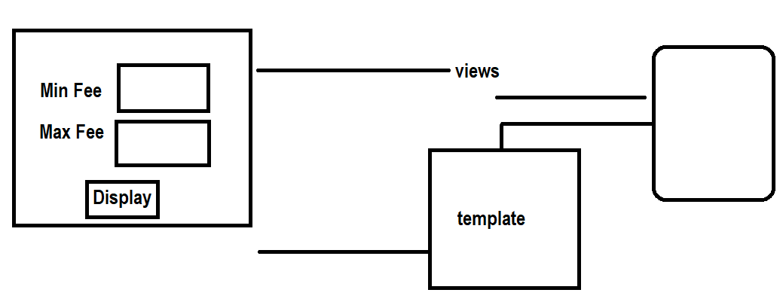

Views.py
from django.db.models import Q
def feeview(request):
min_fee=float(request.GET.get("min_fee"))
max_fee=float(request.GET.get("max_fee"))
qs=Student.objects.filter(Q(fee__gt=min_fee) & Q(fee__lt=max_fee))
response=render(request,"feetemp.html",context={'qs':qs})
return response
def feehome(request):
response=render(request,"feetemp.html")
return response

feetemp.html
<!DOCTYPE html>
<html lang="en">
<head>
<meta charset="UTF-8">
<meta name="viewport" content="width=device-width, initial-scale=1.0">
<title>Document</title>
</head>
<body>
<form action="/feeview">
<table border="2" width="100%">
<tr>
<td>MinFee</td>
<td><input type="text" name="min_fee"></td>
</tr>
<tr>
<td>MaxFee</td>
<td><input type="text" name="max_fee"></td>
</tr>
<tr>
<td><input type="submit" value="Display"></td>
<td><input type="reset" value="Clear"></td>
</tr>
</table>
</form>
<table border="2" width="100%">
<tr>
<td>Rollno</td>
<td>StudentName</td>
<td>StudentCourse</td>
<td>StudentFee</td>
</tr>
{%for stud in qs%}
<tr>
<td>{{stud.rollno}}</td>
<td>{{stud.name}}</td>
<td>{{stud.course}}</td>
<td>{{stud.fee}}</td>
</tr>
{%endfor%}
</table>
</body>
</html>

Urls.py
from app1.views import feeview,feehome
path('feeview/',feeview),
path('feehome/',feehome),

exclude()
It is a method of model manager read all the records from database table except given condition. Exclude is equal to not operation.
This method returns queryset object

Syntax: model-name.objects.exclude(condition)

>>> qs3=Student.objects.exclude(course='python')
>>> for stud in qs3:
... print(stud.rollno,stud.name,stud.course,stud.fee)
...
2 suresh java 2000.0
3 kishore c++ 1000.0
4 ramesh c++ 1500.0
5 kiran c 1000.0
>>> qs4=Student.objects.exclude(fee__lt=2000)
>>> print(qs4)
<QuerySet [<Student: Student object (1)>, <Student: Student object (2)>]>
>>> for stud in qs4:
... print(stud.rollno,stud.name,stud.course,stud.fee)
...
1 naresh python 3000.0
2 suresh java 2000.0
>>>

first()
first method of model manager return first row/record.
It returns first row as a model instance

>>> stud1=Student.objects.first()
>>> print(stud1)
>>> print(stud1.rollno,stud1.name,stud1.course,stud1.fee)
1 naresh python 3000.0
>>>

>>> qs=Student.objects.all()
>>> print(qs)
<QuerySet [<Student: Student object (1)>, <Student: Student object (2)>, <Student: Student object (3)>, <Student: Student object (4)>, <Student: Student object (5)>]>
>>> stud1=qs.first()
>>> print(stud1.rollno,stud1.name,stud1.course,stud1.fee)
1 naresh python 3000.0
>>>

last()
last() method of model manager returns last row as model instance

model-name.objects.last()

>>> from app1.models import Student
>>> stud1=Student.objects.last()
>>> print(stud1)
Student object (5)
>>> print(stud1.rollno,stud1.name,stud1.course,stud1.fee)
5 kiran c 1000.0
>>> qs=Student.objects.all()
>>> stud1=qs.last()
>>> print(stud1.rollno,stud1.name,stud1.course,stud1.fee)
5 kiran c 1000.0
>>>

order_by()

order_by method of model manager read data from model/table in ascending or descending order of specific column
order_by method returns queryset object.

Syntax: model-name.objects.order_by(“column-name”)
Syntax: model-name.objects.order_by(“-column-name”)

>>> from app1.models import Student
>>> qs=Student.objects.order_by("rollno")
>>> print(qs)
<QuerySet [<Student: Student object (1)>, <Student: Student object (2)>, <Student: Student object (3)>, <Student: Student object (4)>, <Student: Student object (5)>]>
>>> for row in qs:
... print(row.rollno,row.name,row.course,row.fee)
...
1 naresh python 3000.0
2 suresh java 2000.0
3 kishore c++ 1000.0
4 ramesh c++ 1500.0
5 kiran c 1000.0
>>> qs=Student.objects.order_by("name")
>>> for row in qs:
... print(row.rollno,row.name,row.course,row.fee)
...
5 kiran c 1000.0
3 kishore c++ 1000.0
1 naresh python 3000.0
4 ramesh c++ 1500.0
2 suresh java 2000.0
>>> qs=Student.objects.order_by("-fee")
>>> for row in qs:
... print(row.rollno,row.name,row.course,row.fee)
...
1 naresh python 3000.0
2 suresh java 2000.0
4 ramesh c++ 1500.0
3 kishore c++ 1000.0
5 kiran c 1000.0
>>>

values()
values() method of model manager returns queryset object
values() method of model manager read data from specific fields

Syntax: model-name.objects.values(‘fieldname’,’field-name’,..)

>>> qs=Student.objects.values('rollno','name')
>>> print(qs)
<QuerySet [{'rollno': 1, 'name': 'naresh'}, {'rollno': 2, 'name': 'suresh'}, {'rollno': 3, 'name': 'kishore'}, {'rollno': 4, 'name': 'ramesh'}, {'rollno': 5, 'name': 'kiran'}]>
>>>
>>> qs=Student.objects.values('rollno','course','fee')
>>> print(qs)
<QuerySet [{'rollno': 1, 'course': 'python', 'fee': 3000.0}, {'rollno': 2, 'course': 'java', 'fee': 2000.0}, {'rollno': 3, 'course': 'c++', 'fee': 1000.0}, {'rollno': 4, 'course': 'c++', 'fee': 1500.0}, {'rollno': 5, 'course': 'c', 'fee': 1000.0}]>
>>>

>>> for stud in qs:
... print(type(stud))
...
<class 'dict'>
<class 'dict'>
<class 'dict'>
<class 'dict'>
<class 'dict'>
>>> for stud in qs:
... print(stud['rollno'],stud['course'],stud['fee'])
...
1 python 3000.0
2 java 2000.0
3 c++ 1000.0
4 c++ 1500.0
5 c 1000.0
>>>
>>> qs=Student.objects.all()
>>> qs1=qs.values('rollno','name')
>>> print(qs1)
<QuerySet [{'rollno': 1, 'name': 'naresh'}, {'rollno': 2, 'name': 'suresh'}, {'rollno': 3, 'name': 'kishore'}, {'rollno': 4, 'name': 'ramesh'}, {'rollno': 5, 'name': 'kiran'}]>
>>>

Sum()
Min()
Max()
Avg()

